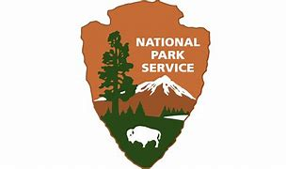

**National Park Service**

**U.S. Department of the Interior**

**Fire Ecology Assessment for Saguaro National Park: Updated QAQC process, Analysis, and Recommendations**

April 2024

Eva Deegan, SIP Intern

Windy Bunn, Fire Ecologist

National Park Service

Intermountain Region

Contents

**Figures** 2

**Appendices** 2

**Summary** 2

**Introduction and Background** 2

**Fire Ecology Program History** 2

**Update to QAQC process** 2

**Fire Effects Analysis** 3

**Management Recommendations** 4

**Literature Cited** 4

## **Figures**

**Figure 1.** Douglas Fir plots seedling density over time by species and size class.

**Figure 2.** Douglas Firplots fuel loading (tons/acre) over time.

**Figure 3a.** Fuel loading (tons/acre) in Douglas Fir plots by size class adjusted to y scale.

**Figure** **3b.** Fuel loading (tons/acre in Douglas Fir plots by size class at a fixed y scale.

## **Appendices**

Appendix A: SAGU_goalsobjs.docx

Appendix B: Documentation on QAQC FFI R packages

Appendix C: Saguaro FFI QAQC Process.docx

## **Summary**

## This assessment is intended to provide information to Saguaro National Park managers about the state of Saguaro’s Fire Ecology Program and summarize results from the QAQC and analysis work performed the past year (2023 – 2024).

## **Introduction and Background**

## **Fire Ecology Program History**

The fire effects data in Saguaro National Park was last analyzed in 2017, after which staffing shortages made progress difficult. The vegetation monitoring crew at SODN and fire effects crews from other parks have assisted in collecting data while Saguaro hasn’t had its own crew. In the summer of 2023, Eva Deegan, an SIP intern mentored by Windy Bunn and Sarah Studd, was hired, and began work on the quality control and analysis of FFI data for Saguaro NP. In spring 2024, Gabe De Jong was hired as the new fire ecologist for Saguaro NP, a position that had been vacant since 2017.

## **Update to QAQC process**

Previously, QAQC for fire effects data in Saguaro National Park was performed with saved queries in the FFI database. During her internship, Eva wrote code in R to obtain the same QAQC results as the saved queries in a quicker, automated process. She developed a package of functions to flag quality control errors in FFI data from the different protocols collected in Saguaro. This updated QAQC process is thoroughly documented in Appendix C. Saguaro FFI QAQC Process.docx.

**Figure 1.** Sample event function historical data summary output

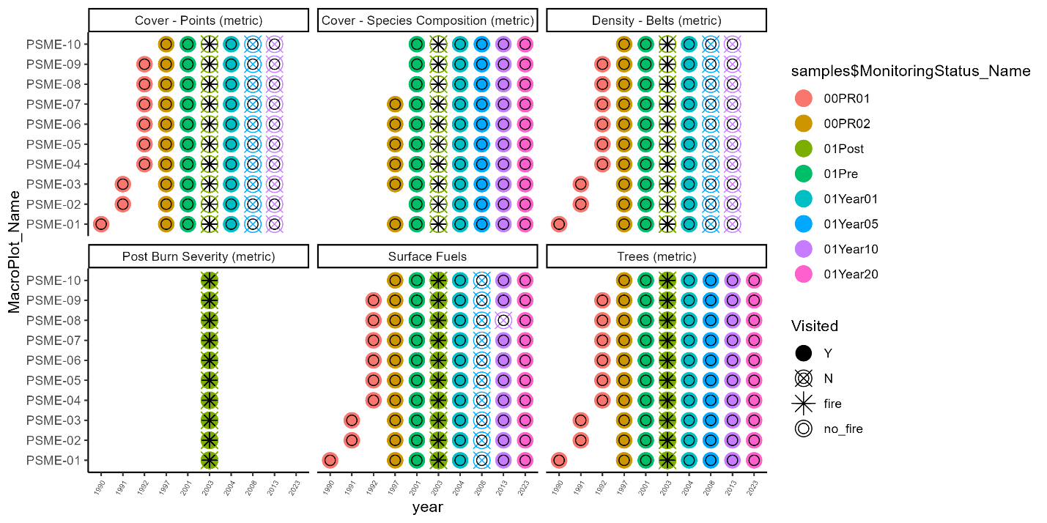

## **Fire Effects Analysis**

## **Management Recommendations**

## **Literature Cited**